STATEMENT OF WORK

KAUST: FACILITY MANAGEMENT CONTRACTS SYSTEM

**Date:** 6th Oct 2020

**Submitted to:**

King Abdullah University of Science and Technology

Thuwal, Saudi Arabia

**Submitted by:**

Pradnya Salvekar, VP Delivery

Extentia Information Technology Pvt. Ltd.

Extentia Tower, Road 12A, Kalyani Nagar  
Pune – 411006, India

E-Mail: [pradnya.salvekar@extentia.com](mailto:pradnya.salvekar@extentia.com)

Table of Contents

Executive Summary 3

Scope of Work 3

Mind Maps 4

Assumptions 7

Dependencies 7

Out Of Scope 8

Project Risk 8

Technology Stack 8

Deliverables 9

Milestones and Timelines 9

# **Executive Summary**

The King Abdullah University of Science and Technology (KAUST) is willing to develop **“Facility Management Contracts System [FMCS]”** to automate contracts management. The System will be working as communication channel between FM Contractors and FM Procurement Team.

**Objective for developing FMCS:**

* An internet face platform to communicate with Contractors
* Archive information and documents
* One unified channel of communication (reduce emails/phone calls traffic)
* Faster reference for future events
* Better deployment of resources

Extentia proposes to design and develop an **“Facility Management Contracts System [FMCS]”** as a responsive web portal.

This document details Extentia’s proposed business models and approximate cost estimates for developing this solution. It also covers the responsibilities of each party for successful project implementation.

# **Scope of Work**

The scope of work includes design and development of Facility Management Contracts System to automate contracts management. The high-level features are as mentioned below:

* System will be able to pull FM Requests from FMRequest system and contractor (vendor) names from FMIMS system.
* Admin will be able to view contractor (vendor) details and manage Roles, Users & Email Templates.
* Contract Manager will be able to view all the FM requests (pulled from FMRequest system), manage contracts, view proposal details, approve/ reject/ cancel proposals submitted by contractors (vendors) and award contracts to contractors (vendors).
* Contractors (vendors) will be able to view contracts assigned to them, export contracts to pdf, manage proposal drafts, submit/ update proposal and view proposal details.
* System Administrator users will be able to only view contracts and proposals, manage users and contractors (vendors) in the system.
* Audit data Logs will be maintained for actions by users.
* Appropriate email notifications will be sent to contractors (vendors) on assignment, update, cancellation of contract and on approval, rejection and cancellation of proposals. Contractors (vendors) will also be notified when contract gets awarded to them.
* A workflow will be managed to award contracts to contractors (vendors) which will mainly have following steps-
  + Creation of contract based on FM requests by Contracts Manager
  + Assignment of contract to contractors (vendors) for requesting proposals
  + Proposal submission/ update by contractors (vendors)
  + Approval/ rejection/ cancellation of proposals by Contract Manager
  + Awarding contract to contractors (vendors)

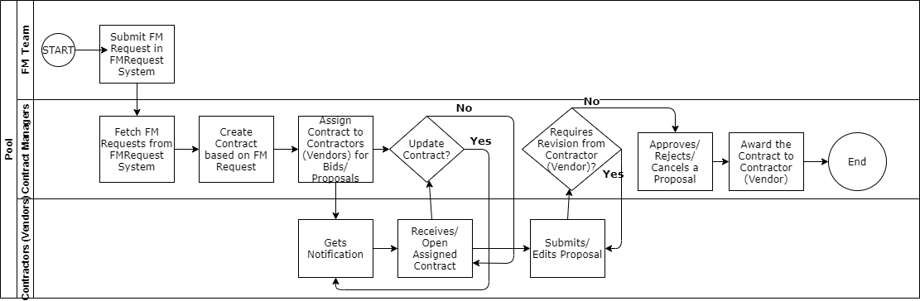

***Figure 1- Swimlane diagram for Contract creation, proposal submit and award contract process***

# **Mind Maps**

The Mind Map below provides a high-level visual representation of the core solution and the features available to the users of the system.

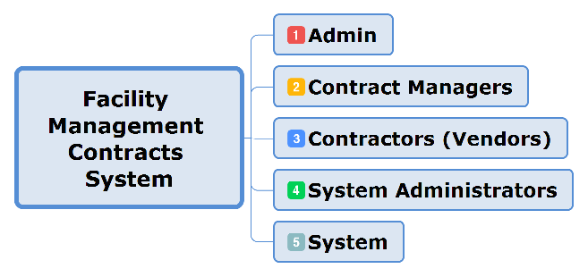

***Figure 2- Overview of Facility Management Contracts System***

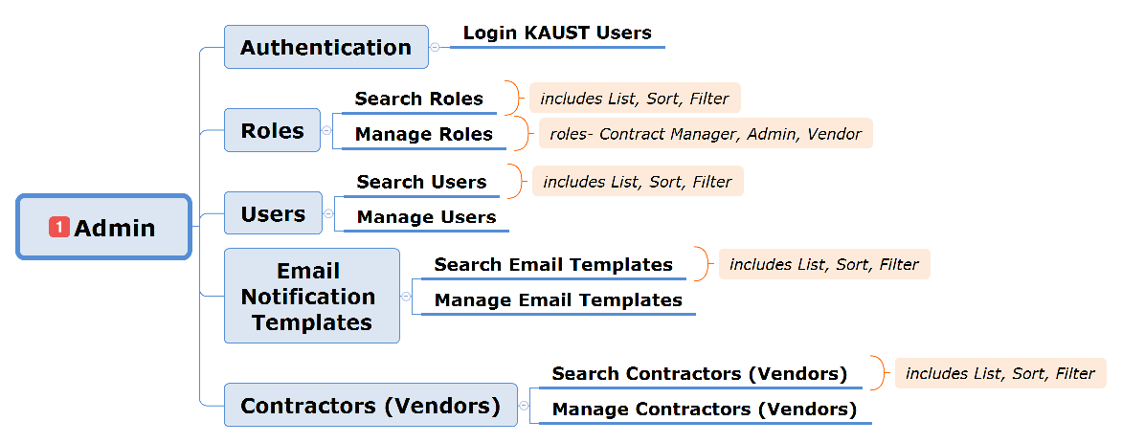***Figure 3- Admin role and its features***

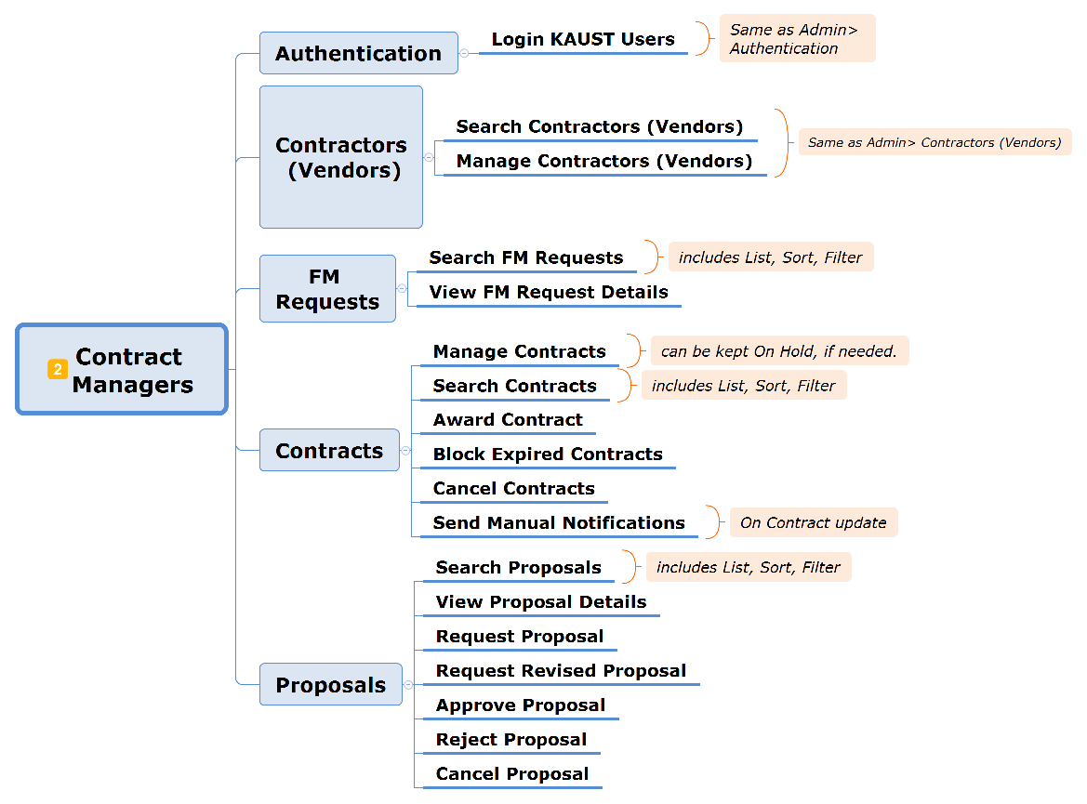

***Figure 4- Contract Manager role and its features***

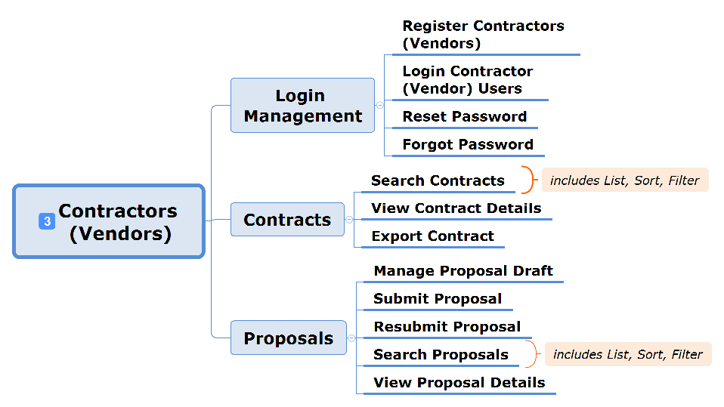

***Figure 5- Vendor role and its features***

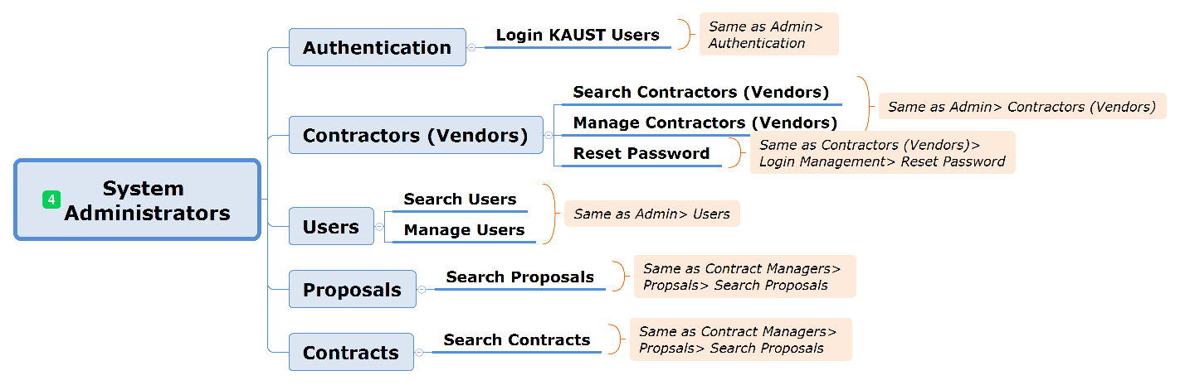***Figure 6- System Administrators role and its features***

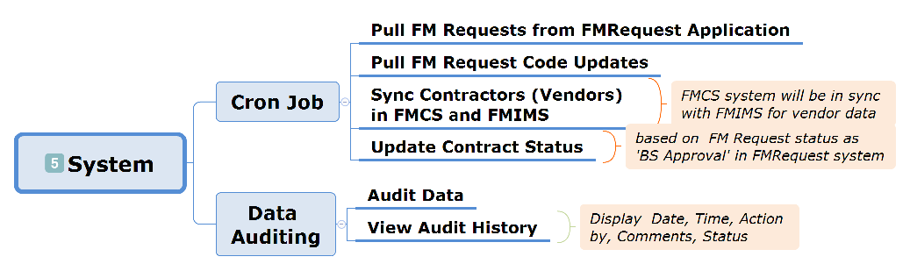

***Figure 7- System features***

# **Assumptions**

* Application will be developed and maintained through the Client’s Tenant infrastructure. Client will share all the required access rights and credentials.
* KAUST and Extentia with mutual understanding will manage creation and maintenance of a detailed project plan including milestones, review and approval cycles, deliverable-specific sprints as well as all subsequent phases like testing and deployment.
* Extentia will follow KAUST’s existing Microsoft based application as a reference for UX design.
* The design of all UI’s, views, controls/components etc. will follow latest UI Guidelines as default and proposed designs (in any) will be approved by Client before implementation.
* The estimates are based on the initial discussion that were conducted with the client. Any change in the scope/complexity/screen count will affect the estimates and timeline. Inclusion of feature change request will be handled by removing low priority feature so that it will be accommodate in the project plan.
* Post completion of project if any further data changes or addition is required will be handled at a separate cost on T&M basis.
* Application will support English language only.
* Contractor (vendor) details will be synced between (sync API needs to be designed) FMIMS and Facility Management Contracts systems.
* Admin will be able to add multiple representatives for the contractors (vendors) as users of the system.
* Email templates will be in plane text.
* User id and password for contractor (vendor) representatives will be generated and stored in Facility Management Contracts System.
* FM Requests will be first converted to Contracts and then only will be assigned to vendors.
* User acceptance Test (UAT Phase) will follow post feature completion milestone for 1 to 2 weeks for the Client’s feedback.
* Extentia will provide required support for the Go-Live immediately post UAT Phase. If the Go-Live date is delayed, then the Go-Live support will be charged on T&M basis.

# **Dependencies**

* Access to the development, testing and production environment.
* Integration and configuration details for KAUST AD system.
* Availability of servers such as SMTP server, Legacy System (Database and App Server)
* Before implementation, there will be design phase where all the mockups and workflows will be finalized.
* KAUST will provide all the field details and associated data validation details.
* KAUST will share all the static content, if any.
* KAUST will provide necessary details for API integrations and access rights for-
  + FMRequest
  + FMIMS
* FMIMS and FMRequest systems should be up and running.
* KAUST will share all required Email templates with from address, Subject and email content.
* Cost of JIRA tool and any other 3rd party tools/plugins required for project will be borne by KAUST and required credentials and access details will be shared with Extentia.
* Access to source control tool (e.g. Gitlab)
* PDF convertor tool access details

# **Out Of Scope**

* Multilingual support.
* Availability of servers such as SMS API gateway, SMTP server, Legacy System (Database and App Server), Network connectivity and speed.
* Data Migration from existing system/application (if any) to new system.
* AMC/Operations support.
* 3rd Party Audit and any impact on additional work due to 3rd Party Audit if conducted by KAUST is not considered in this scope of work and not estimated in this proposal. Extentia will provide the separate costing as and when requested or if need arises.

# **Project Risk**

* Delays in providing access rights for Tenant, Infrastructure, Application Server and Database Server.
* Feature change request during status review meetings.
* Technology and Architecture changes during implementation

# **Technology Stack**

This application has following technology stack and based on the available infrastructure and services the final stack will be considered.

* Windows Server 2012+
* .NET Core 3.1 SDK
* Angular 8.0+
* Google Material Design (material.io)
* Entity Framework (EF) Core
* MS SQL Server Express (64 Bit) + SQL Server Management Studio
* Internet Information Services (IIS) 10

**UI Test Matrix**

The application will be tested on below desktop and mobile browser versions and resolutions for responsive.

**Desktop/Laptop Browser test matrix:**

* Chrome and Mozilla Firefox browser for windows platform with latest versions only for below resolutions:
  + 1366 x 768
  + 1920 x 1080
* Mac Safari browser for Macintosh platform with latest versions for below resolutions:
  + 1367 x 768
  + 1921 x 1080

**Mobile Browser test matrix:**

* Chrome browser for Android Mobile/Tablet devices with latest versions only for below resolutions:
  + 720 x 1280
  + 1080 x 1920
  + 1440 x 2560
  + 2560 x 1600
* Mac Safari browser for iPhone/iPad devices with latest versions for below resolutions:
  + 750 x 1334
  + 1920 x 1080
  + 2436 x 1125
  + 2049 x 1536

# **Deliverables**

* Project plan

Source code

# **Milestones and Timelines**

* The time for this project is estimated to be **10 to 12 weeks** after the kickoff period during which a detailed scope will be discussed and appropriate resources are allocated.
* Extentia will assign appropriate design, architecture, usability, development, and QA staff from one or more of our offices.
* While most of our development work is executed from our offices in India or designated work places, our ability to have some overlap hours with KAUST’s business hours means that Extentia can meet the strict delivery date better than any other organization.